Chapter 14, Solution 69.

This is a highpass filter with 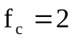 kHz.
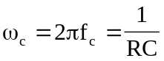
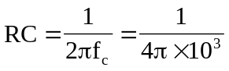

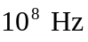 may be regarded as high frequency. Hence the high-frequency gain is
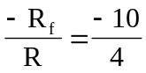 or 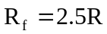

If we let 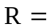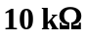, then 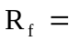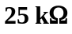, and 

